M a r y l a n d C o m b i n e d T r a i n i n g A s s o c i a t i o n

THE NORTH AMERICAN SPORT PONY TROPHY (HS22)

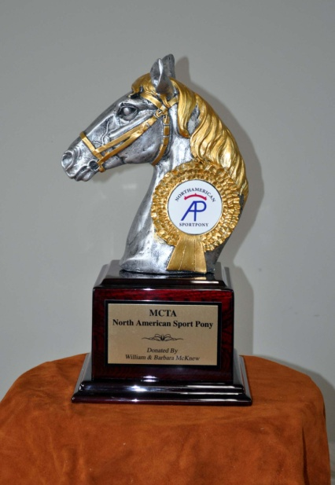

This special trophy was awarded to the registered North American Sport Pony owned and ridden by an MCTA member of any age accumulating the most points in either recognized or unrecognized horse trials. It was kindly donated by William and Barbara McKnew of Little Giants Farm in Bowie. Having been won twice by the same pony, it was retired after the 2012 season.

2011 DBL Copper Twist LG (Felicia McKnew)
2012 DBL Copper Twist LG (Felicia McKnew)

