M a r y l a n d C o m b i n e d T r a i n i n g A s s o c i a t i o n

THE SUNWOOD SPRING TROPHY

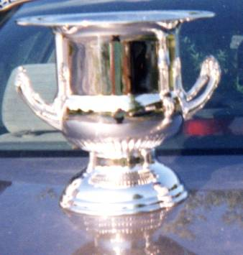

A companion to the Sunstone Creek Trophy, this wine cooler was also donated in 2007 by Ruth Frey. It honors “Piglet” (a.k.a. Arnold), a successful Maryland-bred race horse before helping MCTA’s team place second at Gladstone and then becoming MCTA’s Novice high score winner in 1983, on the occasion of his thirty-first birthday. It is for Senior members at the Novice level of the MCTA Starter Horse Trials.

- Trish Gray (Adieu / Brenda Herzog)

- Amy Boccia (Whisper Lea)
- Amy Boccia (Whisper Lea)
- Barbara Dreyer (Sweet Indulgence)
- Pam Hornbeck (K.C. Jones)
- Morgan Cillo (Don’t Call Me Sugar)
- Angela Bailey (Sir Dudley W)
- Kristy Attman (Be My Lady Malabar)
- Amy Boccia (Firefly)
- Teresa Martinoli (Loughnatousa Caprice)
- Ann Hanlin (Woodrow)
- Kathi Law (Brooklynville)
- Veronica Mallett (Southern Bay)
- Kathi Law (Brooklynville)
- Veronique Mallet (Southern Bay)
- Veronique Mallet (Southern Bay)

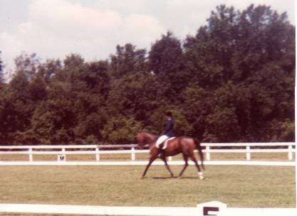 | 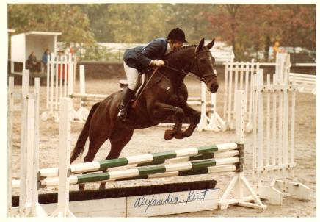 | 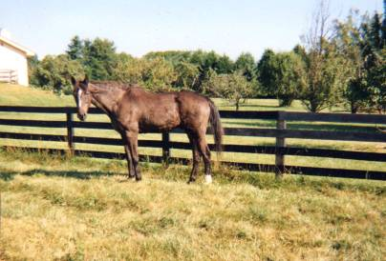
Sunwood Spring starting his Jumping a clear stadium round in the And enjoying retirement at age
eventing career with a win at the pouring rain at Gladstone in 1983, 32 in 2008.
MCTA combined tests in 1982, Alexandra Kent photo
Ed Johnson photo

